**DATA ANALYSIS**

Diversity indices (abundance, richness, evenness, dominance, Simpson’s, and Shannon-Wiener H′ indices) were computed using PAST software (version 4.13). To assess the impact of the waiting period on these indices, a Generalized Linear Model (GLM) with a log link was employed using the glm function of lme4 R package. Abundance was compared across three sampling periods using a Poisson distribution, while other indices with a Gamma distribution. To investigate the influence of waiting days on each diversity index we used a Generalized Linear Model with Mixed Effects (GLMM). For abundance, a Poisson distribution with a log link was applied. Other indices were likewise analyzed, but using a Gamma distribution with the log link. However, Shannon and Simpson's diversity indices encountered computational challenges in the glmer function; due to three out of 108 observations being non-positive (as Zeros). To address this, the observations were excluded to allow for computation. We ran these GLMMs using days of sampling as the explanatory variable, for each diversity indices (as the response variable). Since different pitfall traps were used, and multiple collections were made temporally and spatially with likely dependencies, we used Pitfall traps as the random effect. These analyses as well as figures were done in R version 4.1.3- "One Push-Up”.

**RESULT**

A total of 2,593 individual ants, representing diverse species such as *Camponatus vividus*, *Paltothyreus tarsatus*, *Tetramorium* species, *Odontomachus troglodytes*, and others, were collected across three sampling periods, with 996 ants in the initial period, 1,140 ants in the second, and 457 ants in the third. The other species are *Pheidole welgelegenensis*, *Nylanderia jaegerskioeldi*, *Crematogaster* species, *Monomorium* cf. *salomonis*, *Ph. megacephala*, *Adelomyrmex* sp., *Anomychomyrma* sp., *Monomorium* species, *Austromorium* sp., *Tetramorium* *sericeiventre,* *Loweriella* sp., and seven other unidentified morphospecies of ants.

Ant abundances were relatively high in the first two sampling periods, with medians of 79.5 ±32.68 and 79.5 ±49.27 but decreased to 33.0 ±12.27 in the third period with the longest waiting period (Fig 1a). Significantly (p > 0.05) differences were observed in ant abundance between the first and second sampling period; however, there was significant reduction and stability from the first sampling days of the last period, which had relatively more catches with higher abundance compared to others within the same sampling period (Fig. 1a). Species dominance decreased with increasing waiting period (Fig. 1b) but slightly peaked during the second sampling period (0.56±0.24) (Fig. 1b). However, the last period showed significantly (p < 0.05) lower dominance than the preceding periods. Contrastingly, species evenness generally increased across the three sampling periods (Fig. 1c) as the sampling days progressed, although the second sampling period had a lower index (Fig. 1c). In terms of the sampling periods, Shannon and Simpson’s indices were significantly higher in the last sampling period than the initial two sampling periods (Fig. 1d & 1e).

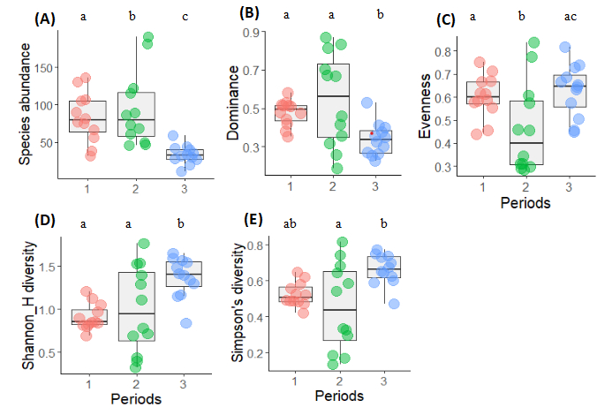

Figure 1: The distribution of epigaeic ants in pitfall traps among three distinct sampling periods as shown for (A) species abundance, (B) dominance, (C) evenness, (D) Shannon H index and (E) Simpson’s index. Any box plots followed by the same letter above them are not significantly (*p* > 0.05) different.

For the GLMMs, results relevant to our research hypothesis were summarized in Table 1. We detected a significant negative relationship between ant abundance and waiting for day intervals (Z= -11.09; p < 0.001). There were some outliers in abundance at the incept of the second ant collection period, which stepped down as collection continued (Fig. 2a). Also, dominance reduced significantly (t= -2.752; p< 0.01) with increasing waiting days (Fig. 2b). Evenness did not differ significantly (P>0.05) with time (Fig. 2c). Conversely, the epigaeic Simpson and Shannon diversity estimates for the ants increased with the extended duration of collection days (Fig. 2 d & e).

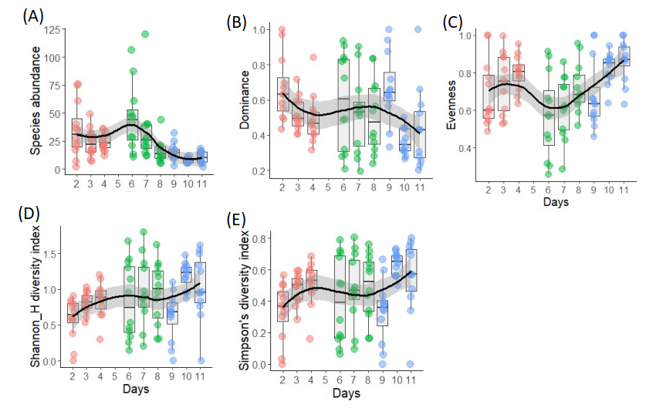

Figure 2: The daily distribution of epigaeic ants in pitfall traps among three distinct sampling periods (coloured as red, green, blue indicating period 1-3; *see* fig 1) as shown for (A) species abundance, (B) dominance, (C) evenness, (D) Shannon H index and (E) Simpson’s index. Coloured dots represent the diversity indices of ants in each pitfall trap (Red; pitfall traps 1-12, green: pitfall traps 13-24, blue: pitfall traps 25-36). The black smooth spline line shows the trend in the ant diversity index, with the grey band indicating its standard error (computed in Rs method = "loess").

Table 1: Results for GLMM using waiting days as the independent variable (n=9).

|  |  |  |  |  |
| --- | --- | --- | --- | --- |
| Diversity indices | Fixed effects (intercept + slope estimate (x)) | Standard error  (intercept + slope (x)) | Z/t value | P value |
| Abundance | 4.7102 - 0.2640x | 0.1890 + 0.0238x | -11.09 | <0.001 |
| Evenness | -0.54106 +0.02969x | 0.11260 + 0.01537x | 1.932 | >0.05 |
| Dominance | -0.28506 -0.06016x | 0.15590 +0.02186x | -2.752 | <0.01 |
| Simpsons | -1.14559 +0.05483x | 0.19444 +0.02604x | 2.106 | <0.05 |
| Shannon_H | -0.59283 +0.06355x | 0.17691 +0.02369x | 2.683 | <0.01 |

Note: Z value is computed for only abundance (with Poisson distribution); other indices retain t values.

|  |  |  |  |  |
| --- | --- | --- | --- | --- |
| Table 1: Results for GLMM Diversity indices | Regression equation (intercept + slope estimate (x)) | Standard error  (intercept + slope estimate (x)) | Z/t value | P value |
| Abundance | 4.7102 + | 0.1890 + | 24.93 | <0.001 |
|  | -0.2640 | 0.0238 | -11.09 | <0.001 |
| Evenness | -0.54106 + | 0.11260 + | -4.805 | <0.001 |
|  | 0.02969 | 0.01537 | 1.932 | >0.05 |
| Dominance | -0.28506 + | 0.15590 + | -1.828 | <0.05 |
|  | -0.06016 | 0.02186 | -2.752 | <0.01 |
| Simpson_1.D | -1.14559 + | 0.19444 + | -5.892 | <0.001 |
|  | 0.05483 | 0.02604 | 2.106 | <0.05 |
| Shannon_H | -0.59283 + | 0.17691 + | -3.351 | < 0.001 |
|  | 0.06355 | 0.02369 | 2.683 | <0.01 |

Table 2: GLM table for Periods

|  |  |  |  |  |  |
| --- | --- | --- | --- | --- | --- |
| Diversity indices | | Regression equation (intercept + slope estimate (x)) | Standard error  (intercept + slope estimate (x)) | Z/t value | P value |
| Abundance | Intercept | 3.32023 | 0.03169 | 104.785 | <0.001 |
|  | Period 2 | 0.12623 | 0.04346 | 2.904 | <0.01 |
|  | Period 3 | -0.89003 | 0.05873 | -15.155 | <0.001 |
| Evenness | Intercept | -0.29593 | 0.03879 | -7.630 | <0.001 |
|  | Period 2 | -0.15669 | 0.05485 | -2.856 | <0.01 |
|  | Period 3 | 0.05466 | 0.05485 | 0.996 | >0.05 |
| Dominance | Intercept | -0.58380 | 0.06535 | -8.933 | <0.001 |
|  | Period 2 | -0.03244 | 0.09242 | -0.351 | >0.05 |
|  | Period 3 | -0.13234 | 0.09242 | -1.432 | >0.05 |
| Simpson_1.D | Intercept | -0.78774 | 0.06676 | -11.800 | <0.001 |
|  | Period 2 | 0.01128 | 0.09375 | 0.120 | >0.05 |
|  | Period 3 | 0.17423 | 0.09510 | 1.832 | >0.05 |
| Shannon_H | Intercept | -0.26257 | 0.06697 | -3.921 | <0.001 |
|  | Period 2 | 0.17660 | 0.09405 | 1.878 | >0.05 |
|  | Period 3 | 0.27447 | 0.09540 | 2.877 | <0.01 |

Table 2: GLM table for Periods correct (without releveling)

|  |  |  |  |  |  |
| --- | --- | --- | --- | --- | --- |
| Diversity indices | | Regression equation (intercept + slope estimate (x)) | Standard error  (intercept + slope estimate (x)) | Z/t value | P value |
| Abundance | Intercept | 4.41884 | 0.03169 | 139.457 | <0.001 |
|  | Period 2 | 0.12534 | 0.04347 | 2.883 | <0.01 |
|  | Period 3 | -0.90481 | 0.05904 | -15.326 | <0.001 |
| Evenness | Intercept | -0.50629 | 0.08087 | -6.261 | <0.001 |
|  | Period 2 | -0.26483 | 0.11437 | -2.316 | <0.05 |
|  | Period 3 | 0.04415 | 0.11437 | 0.386 | >0.05 |
| Dominance | Intercept | -0.74299 | 0.08796 | -8.447 | <0.001 |
|  | Period 2 | 0.13760 | 0.12439 | 1.106 | >0.05 |
|  | Period 3 | -0.34163 | 0.12439 | -2.746 | <0.01 |
| Simpson_1.D | Intercept | -0.64568 | 0.09351 | -6.905 | <0.001 |
|  | Period 2 | -0.14369 | 0.13224 | -1.087 | >0.05 |
|  | Period 3 | 0.23314 | 0.13224 | 1.763 | >0.05 |
| Shannon_H | Intercept | -0.09426 | 0.09276 | -1.016 | >0.05 |
|  | Period 2 | 0.09149 | 0.13118 | 0.697 | >0.05 |
|  | Period 3 | 0.40884 | 0.13118 | 3.117 | <0.01 |

Releveling with ref= S2

Abundance: PeriodS3 -1.03015 0.05803 -17.753 < 2e-16 ***

Evenness: PeriodS3 0.30899 0.11437 2.702 0.0108 *

Dominance: PeriodS3 -0.47923 0.12439 -3.853 0.00051 ***

Simpsons: PeriodS3 0.37682 0.13224 2.850 0.00748 **

Shannon: PeriodS3 0.31735 0.13118 2.419 0.0212 *